Table of Contents
1 Introduction 1
2 Setup and Configuration 1
2.1 Installation 1
2.2 JBoss Developer Studio Configuration 2
2.3 Start the JBoss Enterprise BRMS Platform 3
2.4 Importing Rule Repository 4
3 Running the Demo (TODO) 4
3.1 todo 4

Introduction
This is a BRMS demo application setup guide for the Rewards Demo. The setup will create a fully installed and configured BRMS environment so that you can demo the project in all the available jBPM components. It will provide you with a JBoss Developer Studio project with unit tests to demo the project in the IDE. It will provide a repository that you can import into BRMS BRM and demo the web tooling, web business central admin console and asset manager BRM tooling.

Setup and Configuration

Installation
You first need to extract the demo distribution zip (brms-rewards-demo-1.0.zip) to a location of your choosing. Once extracted, you will have the following folder structure:
- \brms-rewards-demo
  - \installs – Initially empty, but will contain the BRMS platform downloads.
  - \projects – The project that comprise the demo.
  - \support – Additional supporting files used by the demo.
  - \target – Will be created by running init.sh. Contains the fully configured BRMS runtime server.
  - init.sh – Script to install and configure the run time server environment.
  - Quick Start Guide.odt – This document
Next, download JBoss Enterprise BRMS Platform from the Red Hat Customer Portal (https://access.redhat.com/jbossnetwork).
Download BRMS Platform:
- Under JBoss Enterprise Platforms, select the BRMS Platform product.
- Select version 5.3.0 in the Version field.
- Download JBoss BRMS 5.3.0
(Please note that this is the deployable distribution, not the standalone one.)

Now copy brms-p-5.3.0.GA-standalone.zip, to the brms-rewards-demo's installs folder.

Lastly, from the brms-rewards-demo folder, run the init.sh script:

$ ./init.sh

When the script completes you will have a new folder named brms-standalone-5.3.0, in the brms-rewards-demo's target folder. The brms-standalone-5.3.0 folder is a ready to run BRMS 5.3.0 server runtime with the following modifications made:
- The admin, krisv, mary, john, erics accounts enabled (passwords are same as users name) in the brms-roles.properties and brms-users.properties file in brms-customer-evaluation-demo/target/brms-standalone-5.3.0/jboss-as/server/default/conf/props
- The users added in the hypersonicDB-localDB.script copied to brms-customer-evaluation-demo/target/brms-standalone-5.3.0/jboss-as/server/default/data/hypersonic/localDB.script
- The custom work items are activated by adding CustomWorkItemHandlers.conf and drools.session.conf to the jbpm-gwt-console-server at brms-customer-evaluation-demo/target/brms-standalone-5.3.0/jboss-as/server/default/deploy/jbpm-gwt-console-server.war/WEB-INF/classes/META-INF
- The domain model jar customereval-model.jar added to the console at brms-customer-evaluation-demo/target/brms-standalone-5.3.0/jboss-as/server/default/deploy/jbpm-gwt-console-server.war/WEB-INF/lib

JBoss Developer Studio Configuration
In this section, you will configure JBoss Developer Studio. Specifically you will add the BRMS 5.3.0 platform server runtime environment and then import the project that makes up the BRMS Rewards Demo.
Important: It is assumed that you already have JBoss Developer Studio installed. This demo has been tested with JBoss Developer Studio 5 (latest).
Launch JBoss Developer Studio
- Either select or switch to a new workspace by pointing to the brms-rewards-demo/projects folder.
- If the Welcome to JBoss Developer Studio screen appears, dismiss it by click the Workbench arrow in the upper right
Optional: fix for missing GEF dependency in SOA Tools update site
- Select Help → Install New Software... and add GEF update site http://download.eclipse.org/tools/gef/updates/releases/
- Do not select any components, move on to next step to install SOA tools update site and the needed dependencies for GEF will be automatically resolved.
Install SOA tools for BRMS
- Select Help → Install New Software... and add SOA Tools update site https://devstudio.jboss.com/updates/5.0/staging/soa-tooling/
- Select BRMS Tooling, SOA-P Tooling and JBoss SOA Development (all sub-menu items will be selected) and proceed thru installation and restart JBoss Developer Studio to complete the installation. You will be told to restart JBoss Developer Studio for the changes to take effect, do this now.
Detect and add a BRMS 5.3.0 runtime environment
- Select Preferences from the Window menu.
- In the left hand side, expand JBoss Tools and then select JBoss Tool Runtime Detection
- Select the Add button and navigate to the brms-rewards-demo/target folder, then select OK.
- The brms-standalone-5.3.0 runtime created earlier should have been found and selected. If so, select OK.
- Select OK again to close the Preferences dialog window.
Detect and add jBPM BRMS 5.3.0 runtime environment
- Select Preferences from the Window menu.
- In the left hand side, expand JBM and then select Installed jBPM Runtimes
- If not automatically listed in the view: Select the Add button, then the Create a new jBPM Runtime... button and navigate to the brms-rewards-demo/target/brms-standalone-5.3.0 folder, then name the runtime jBPM BRMS 5.3.0 runtime and select OK.
- The jBPM BRMS 5.3.0 runtime should be selected. If so, select OK to close the Preferences dialog window.
- You will be told to restart JBoss Developer Studio for the changes to take effect, do this now.
Detect and add Drools 5.3.1 runtime environment
- Select Preferences from the Window menu.
- In the left hand side, expand Drools and then select Installed Drools Runtimes
- If not automatically listed in the view: Select the Add button, then the Create a new Drools 5 Runtime... button and navigate to the brms-rewards-demo/target/brms-standalone-5.3.0 folder, then name the runtime Drools 5.3.1.Final runtime and select OK.
- Select the Drools 5.3.1.Final runtime.
- In Drools in the left hand side menu select Drools Flow nodes, make sure all boxes are checked (some are unchecked by default, don't ask me why...) and select OK to close the Preferences dialog window.
- You will be told to restart JBoss Developer Studio for the changes to take effect, do this now.
Import Projects
- Select Import... from the File menu.
- Expand the General folder, and then select Existing Projects into Workspace
- Select the Browse button to Select root directory, you should be in the brms-rewards-demo folder (if not, then navigate there) and then select OK.
- Make sure the project (brms-rewards-demo) is selected and then select Finish.
- The projects are now imported.

Start the JBoss Enterprise BRMS Platform
In this section, you will start the server from within JBoss Developer Studio.
- Select the Servers view
If it is currently not open, select Show View --> Other... from the Window menu and search for the Servers view.
- You should see the brms-standalone-5.3.0 server you created earlier.
- Right click on brms-standalone-5.3.0 and select Start from the pop-up menu. In a few moments your JBoss Enterprise BRMS Platform will be running.

Importing Project Repository into BRM
In this section, you will import all of the JBoss Enterprise BRMS artifacts into the Business Rules Manager.
- Open up your Web browser of choice and navigate to http://localhost:8080/jboss-brms/
- Use the default credentials of admin/admin
- Upon logging in, you will see the following prompt:
This looks like a brand new repository.
Would you like to install a sample repository?
Important: Please be sure to select No thanks.
- Select the Administration section on the left hand side
- From the Administration list select Import Export. This will open the Import Export window.
- Now select Browse... and navigate to brms-rewards-demo/support folder and select the repository_export.xml file.
- Lastly, select the Import button. Select OK to confirm that you want to import the artifacts.

Running the Demo (TODO)

JBDS IDE demo
You can demo the project in the JBoss Developer Studio by making use of the editors, running the provided unit tests and watching the console for logged (verbose) output.

ProcessMain
You can run the process from your IDE, you just need the JBoss BRMS server running to provide you with a human task service and follow these steps to demo the functionality:
- Start the JBoss BRMS server in JBDS via the Server tab.
- Select ProcessMain.java file and right-click, Run As..., Java Application and watch the Console tab for output. This has started your process instance and it is waiting in the first human task.
- Go to browser and login to http://localhost:8080/business-central (erics, krisv, admin will all work).
- Open Task tab, select Group Tasks, Refresh, select entry that appears in list, hit Claim button, task will now disappear from list.
- Select Personal Tasks, Refresh, select entry listed, hit View button, fill in form and submit either as Rejected or Accepted as you desire.
- Return to JBDS Console tab and view logged process completion output based on path chosen (Accepted or Rejected).
- You can edit use ProcessMainExtended.java for a bit more verbosity in the output.
Unit Testing
The following will run the demo process with four unit tests:
- Select the file brms-rewards-demo/src/test/java/CustomerEvaluationTest.java, right click, Run As..., JUnit Test.
Your output should look something like illustration 1 and example output of the console logging:
Test 1
Executing work item WorkItem 2 [name=Log, state=0, processInstanceId=1, parameters{Message=Reward for erics: (Amazing demos for JBoss World!), TaskName=Log}]

Test 2
Executing work item WorkItem 2 [name=Log, state=0, processInstanceId=1, parameters{Message=Reward for erics: (Cool demo for JBoss World!), TaskName=Log}]

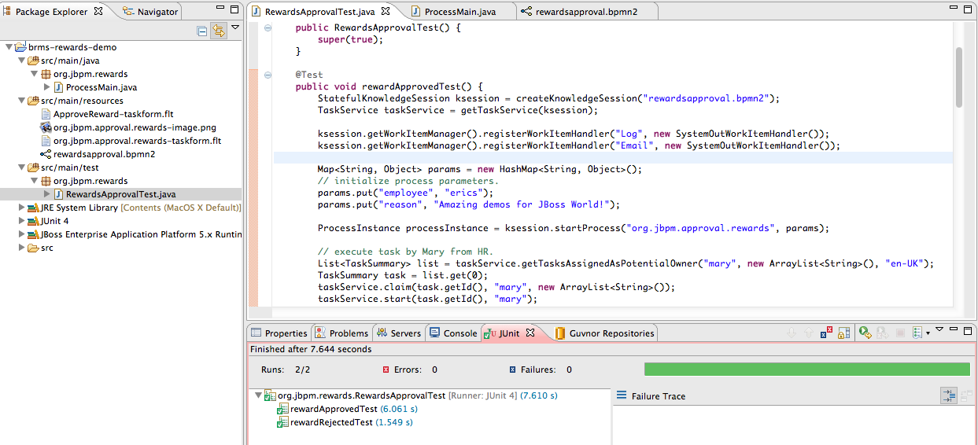Illustration 1: Unit testing Rewards Demo

BRMS BRM demo (todo onwards)
The package was already imported so now we can look closer at web designers viewing, rules asset viewing, package building and deploying, web business central admin console viewing.

Web Designer
The BRM is available on http://localhost:8080/jboss-brms once the BRMS server has been fully started.
- Login with a user (admin, krisv, mary, john, erics available). To start fresh you can at any time import the original repository as follows: Administration → Import Export → Choose File ->brms-customer-evaluation-demo/support/repository-export.xml → Import (Ok to pop-ups)
- View process: Knowledge Bases → Packages → org.jbpm.evaluation.customer → Asset tab → view Processes and Open customereval and wait for web designer to appear.

Rule asset viewing
To view some of the assets in your project:
- Knowledge Bases → Packages → org.jbpm.evaluation.customer → Asset tab → view Technical Rule Assets, Model, Processes, Other assets or WorkItemDefinition.

Build package for deployment
To build your package for deployment:
- Build package: Knowledge Bases → Packages → org.jbpm.evaluation.customer → Edit tab → Build Package button. Now the process has been deployed in the Business Central administration component.

Business Central
The Business Central administration console is available on http://localhost:8080/business-central once the BRMS server has been fully started and after deploying your process by building the package in BRMS BRM.
- Login as user (admin, erics, krisv have same rights).
- On left open Processes tab → Process Overview and you should see Customer Evaluation Demo v0 appear. If not, hit Refresh. If not, ensure the demo package has been built without errors in BRM as described previously.
- Click on Rewards Approval v3 to select this process, then Start button and OK for pop-up.
- You will be presented with a form to fill in for starting this process, add an employee and reason before you hit the submit button. Close the window.
- Click on the running instance, then Diagram button which will pop up with illustration 2 showing the process started and waiting in the first human task node.
- You can view the Instance Data by hitting that button on the left.
- Change to Tasks tab on left, select Group Tasks, select task as it appears, hit Claim button. The task entry should disappear.
- Select Personal Tasks, the previous task will appear in your list, select it, push View button and fill in the Explanation field in the form and submit as Rejected or Approved. Close the window.
- Back to Processes tab, select Process Overview, hit Refresh and the instance that was listed as running should now disappear as it has completed.
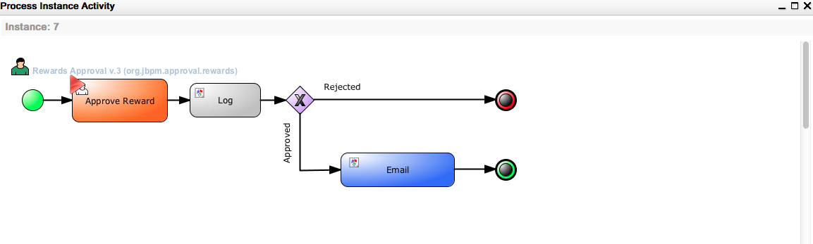Illustration 2: Diagram process in action.

